**Topics: Descriptive Statistics and Probability**

1. Look at the data given below. Plot the data, find the outliers and find out $μ, σ, σ^{2}$

|  |  |
| --- | --- |
| **Name of company** | **Measure X** |
| Allied Signal | 24.23% |
| Bankers Trust | 25.53% |
| General Mills | 25.41% |
| ITT Industries | 24.14% |
| J.P.Morgan & Co. | 29.62% |
| Lehman Brothers | 28.25% |
| Marriott | 25.81% |
| MCI | 24.39% |
| Merrill Lynch | 40.26% |
| Microsoft | 32.95% |
| Morgan Stanley | 91.36% |
| Sun Microsystems | 25.99% |
| Travelers | 39.42% |
| US Airways | 26.71% |
| Warner-Lambert | 35.00% |

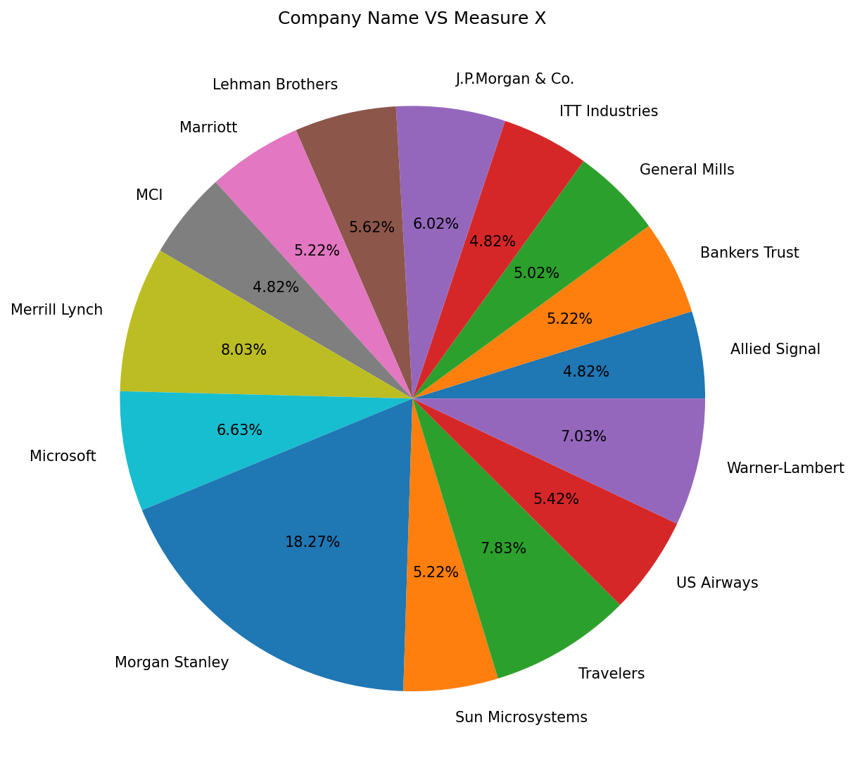

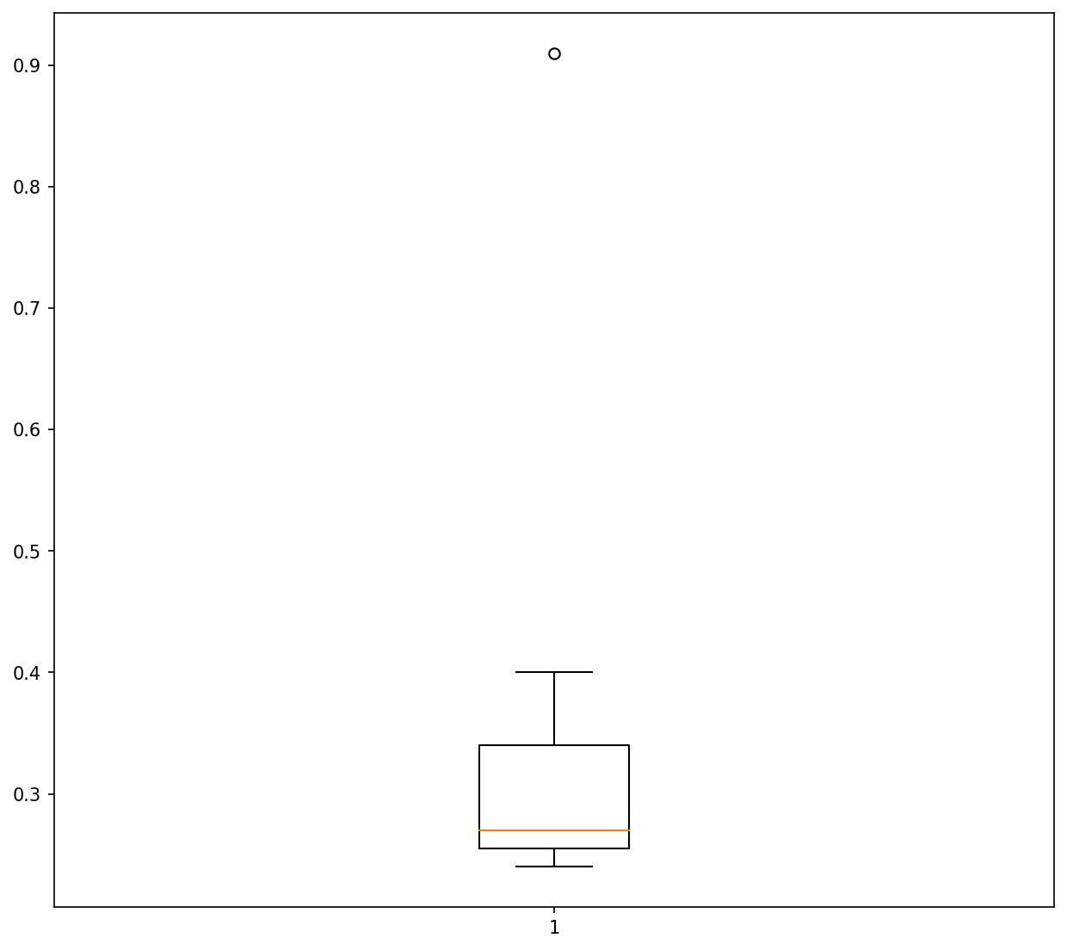

* **There is an Outlier in the Boxplot:** Morgan Stanley 91.36%
* **Population Mean:** 33.28
* **Standard Deviation**: 16.95
* **Variance:** 2.65



**Answer the following three questions based on the box-plot above.**

1. **What is inter-quartile range of this dataset? (please approximate the numbers) In one line, explain what this value implies**.

**Answer: -** First Quantile Range **Q1** = 5

Third Quantile Range **Q3** = 12

Median **Q2** = 7

Inter-Quartile Range **IQR** = Q3 – Q1

= 12 – 5

= 7

1. **What can we say about the skewness of this dataset?**

**Answer: -**

There is Right Skewness in Above Dataset

1. **If it was found that the data point with the value 25 is actually 2.5, how would the new box-plot be affected?**

**Answer: -**

In That Case, there would be no Outliers In the given Dataset.



**Answer the following three questions based on the histogram above.**

1. **Where would the mode of this dataset lie?**

**Answer: -**

The Mode will lie between 4 and 10.

1. **Comment on the skewness of the dataset.**

**Answer: -**

The above Histogram is Right Skewed.

1. **Suppose that the above histogram and the box-plot in question 2 are plotted for the same dataset. Explain how these graphs complement each other in providing information about any dataset.**

**Answer: -**

1. Both the graphs are Right Skewed and have Outliers towards Upper Extreme.
2. We can find the mode of Dataset using Histogram and Using Boxplot we can find the mean and median of the Dataset**.**
3. **AT&T was running commercials in 1990 aimed at luring back customers who had switched to one of the other long-distance phone service providers. One such commercial shows a businessman trying to reach Phoenix and mistakenly getting Fiji, where a half-naked native on a beach responds incomprehensibly in Polynesian. When asked about this advertisement, AT&T admitted that the portrayed incident did not actually take place but added that this was an enactment of something that “could happen.” Suppose that one in 200 long-distance telephone** **calls is misdirected. What is the probability that at least one in five attempted telephone calls reaches the wrong number? (Assume independence of attempts.)**

**Answer: -**

Let's define the events as follows:

E1 = event of a call reaching the wrong number

E2 = event of a call reaching the correct number

E3 = event of at least one in five calls reaching the wrong number

We know that,

P(E1) = 1/200

So,

P(E2) = 1 - P(E1)

= 1 – 1/200

= 199/200

Now,

The probability for at least one in five attempted telephone calls reaches the wrong number:

Number of Calls, n = 5

Here, p = 1/200

q = 199/200

Therefore,

P(E3) = at least one in five attempted telephone calls reaches the wrong number

= **ⁿCₓ pˣ qⁿ⁻ˣ** ( nCr = n! / r! * (n - r)!

= (5C1) (1/200) ^1 (199/200) ^ (5-1)

P(E3) = **0.0245037**

1. **Returns on a certain business venture, to the nearest $1,000, are known to follow the following probability distribution**

|  |  |
| --- | --- |
| x | P(x) |
| -2,000 | 0.1 |
| -1,000 | 0.1 |
| 0 | 0.2 |
| 1000 | 0.2 |
| 2000 | 0.3 |
| 3000 | 0.1 |

**Solution: -**

|  |  |
| --- | --- |
| **E(X) =Sum X.*P(X)** | **E(X^2) =X^2*P(X**) |
| -200 | 400000 |
| -100 | 100000 |
| 0 | 0 |
| 200 | 200000 |
| 600 | 1200000 |
| 300 | 900000 |
| **Total = 800** | **Total = 2800000** |

1. **What is the most likely monetary outcome of the business venture?**

**Answer: -** The most likely monetary outcome of the business venture is **2000$.**

As for **2000$** the probability is **0.3** which is maximum as compared to others.

1. **Is the venture likely to be successful? Explain**

**Answer: -**

Yes, the probability that the venture will make more than 0 or a profit

p(x>1000) +p(x>2000) +p(x=3000) =

= 0.2+0.3+0.1

= **0.6**

this states that there are a good 60% chances for this venture to be making a profit.

1. **What is the long-term average earning of business ventures of this kind? Explain**

**Answer: -**

The long-term average is Expected value = Sum (X * P(X))

= **800$**

which means on an average the returns will be + 800$

1. **What is the good measure of the risk involved in a venture of this kind? Compute this measure**

**Answer: -**

The good measure of the risk involved in a venture of this kind depends on the Variability in the distribution. Higher Variance means more chances of risk

Var (X) = E(X^2) –(E(X)) ^2

= 2800000 – 800^2

= **2160000**

*σ*=Var(*X*)​ ^1/2

*σ*=2160000^1/2

*σ*≈**1470**

Therefore, the measure of risk (standard deviation) for this business venture is approximately $1,470.